

**Name – Tapas Mazumdar ID – 2018A8B40427P**

**Analog Electronics Lab #3 – Design of VCVS, VCCS, CCVS and CCCS using LM741**

**Objectives**

To design the following four topologies using LM741 OPAMP

1. Voltage Controlled Voltage Source (VCVS)
2. Current Controlled Voltage Source (CCVS)
3. Voltage Controlled Current Source (VCCS)
4. Current Controlled Current Source (CCCS) and find

Simulated values of voltage gain (Av) by

* 1. Varying RL with constant source
  2. Varying source with constant RL

Compare the results from simulation with the theoretical values of Av.

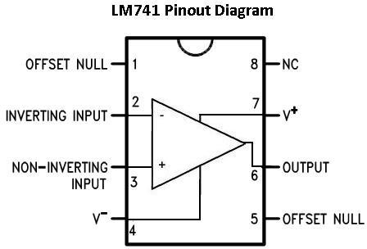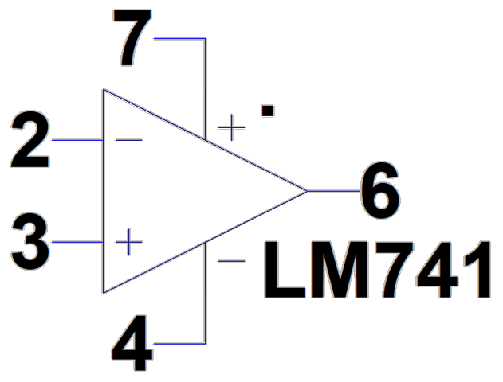

**IC LM-741**

* LM741 operational amplifier is a DC-coupled high gain electronic voltage amplifier.
* It has only one op-amp inside.
* An operational amplifier IC is used as a comparator, which compares the two signal, the inverting and non- inverting signal.
* The main function of this IC is to do mathematical operation in various circuits.
* Op-amps have large gain and usually used as Voltage Amplifier.
* The LM741 can operate with a single or dual power supply voltage.

**Voltage Controlled Voltage Source (VCVS)**

Schematic

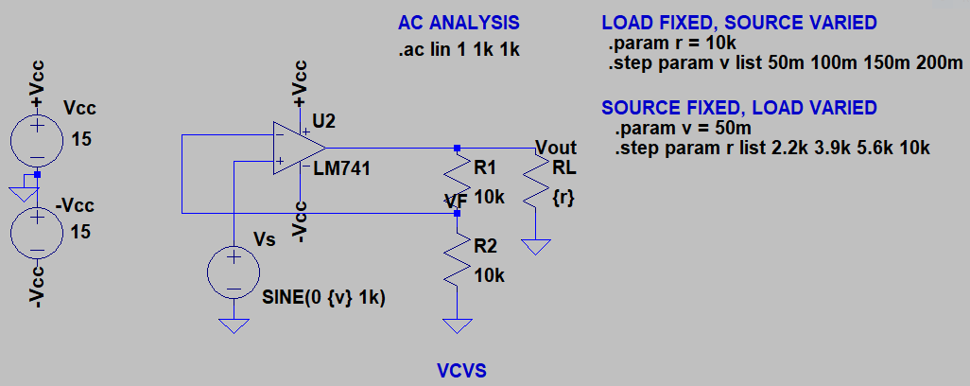

Source Vs = 50mV and load varied

|  |  |
| --- | --- |
|  |  |
|  |  |

Load Rl = 10kΩ and source varied

|  |  |
| --- | --- |
|  |  |
|  |  |

Comparison of simulated and theoretical values

|  |  |  |  |
| --- | --- | --- | --- |
| **Vs (mV)** | **Rl (kΩ)** | **Simulated Av** | **Theoretical Av = 1 + (R1/R2)** |
| 50 | 2.2 | 6.0206012 dB = 2 V/V | 1 + (10kΩ/10kΩ) = 2 V/V |
| 50 | 3.9 | 6.0206012 dB = 2 V/V | 1 + (10kΩ/10kΩ) = 2 V/V |
| 50 | 5.6 | 6.0206012 dB = 2 V/V | 1 + (10kΩ/10kΩ) = 2 V/V |
| 50 | 10 | 6.0206012 dB = 2 V/V | 1 + (10kΩ/10kΩ) = 2 V/V |
|  |  |  |  |
| 50 | 10 | 6.0206012 dB = 2 V/V | 1 + (10kΩ/10kΩ) = 2 V/V |
| 100 | 10 | 6.0206012 dB = 2 V/V | 1 + (10kΩ/10kΩ) = 2 V/V |
| 150 | 10 | 6.0206012 dB = 2 V/V | 1 + (10kΩ/10kΩ) = 2 V/V |
| 200 | 10 | 6.0206012 dB = 2 V/V | 1 + (10kΩ/10kΩ) = 2 V/V |

**Current Controlled Voltage Source (CCVS)**

Schematic

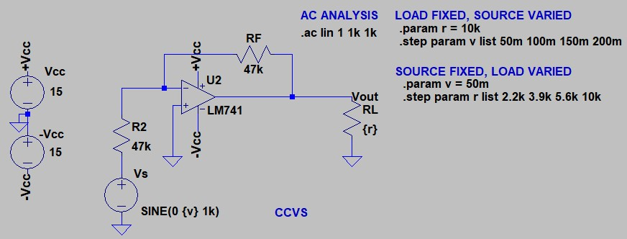

Source Vs = 50mV and load varied

|  |  |
| --- | --- |
|  |  |
|  |  |

Load Rl = 10kΩ and source varied

|  |  |
| --- | --- |
|  |  |
|  |  |

Comparison of simulated and theoretical values

|  |  |  |  |
| --- | --- | --- | --- |
| **Vs (mV)** | **Rl (kΩ)** | **Simulated A** | **Theoretical A = RF** |
| 50 | 2.2 | 93.4419 dB = 46.99969 kΩ | 47 kΩ |
| 50 | 3.9 | 93.441903 dB = 46.99971 kΩ | 47 kΩ |
| 50 | 5.6 | 93.441903 dB = 46.999707 kΩ | 47 kΩ |
| 50 | 10 | 93.441904 dB = 46.999712 kΩ | 47 kΩ |
|  |  |  |  |
| 50 | 10 | 93.441904 dB = 46.999712 kΩ | 47 kΩ |
| 100 | 10 | 93.441904 dB = 46.999712 kΩ | 47 kΩ |
| 150 | 10 | 93.441904 dB = 46.999712 kΩ | 47 kΩ |
| 200 | 10 | 93.441904 dB = 46.999712 kΩ | 47 kΩ |

**Voltage Controlled Current Source (VCCS)**

Schematic

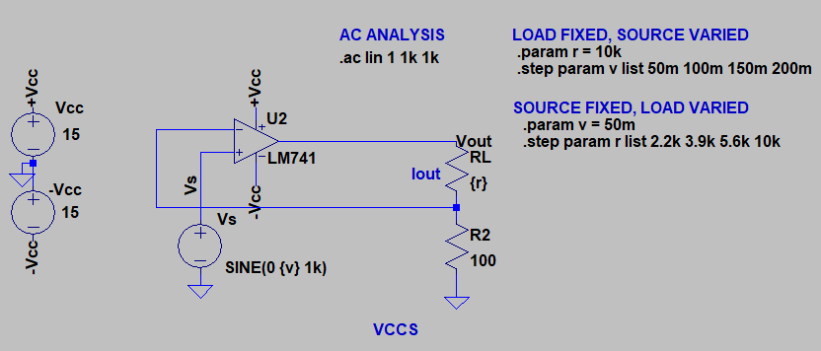

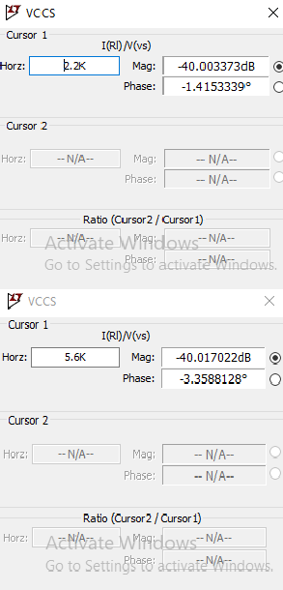Source Vs = 50mV and load varied

|  |  |
| --- | --- |
|  |  |
|  |  |

Load Rl = 10kΩ and source varied

|  |  |
| --- | --- |
|  |  |
|  |  |

Comparison of simulated and theoretical values

|  |  |  |  |
| --- | --- | --- | --- |
| **Vs (mV)** | **Rl (kΩ)** | **Simulated A** | **Theoretical A = 1/R2** |
| 50 | 2.2 | -40.003373 dB = 0.009996 Ω-1 | 1/100Ω = 0.01 Ω-1 |
| 50 | 3.9 | -40.008951 dB = 0.009989 Ω-1 | 1/100Ω = 0.01 Ω-1 |
| 50 | 5.6 | -40.017022 dB = 0.009980 Ω-1 | 1/100Ω = 0.01 Ω-1 |
| 50 | 10 | -40.04938 dB = 0.009943 Ω-1 | 1/100Ω = 0.01 Ω-1 |
|  |  |  |  |
| 50 | 10 | -40.04938 dB = 0.009943 Ω-1 | 1/100Ω = 0.01 Ω-1 |
| 100 | 10 | -40.04938 dB = 0.009943 Ω-1 | 1/100Ω = 0.01 Ω-1 |
| 150 | 10 | -40.04938 dB = 0.009943 Ω-1 | 1/100Ω = 0.01 Ω-1 |
| 200 | 10 | -40.04938 dB = 0.009943 Ω-1 | 1/100Ω = 0.01 Ω-1 |

**Current Controlled Current Source (CCCS)**

Schematic

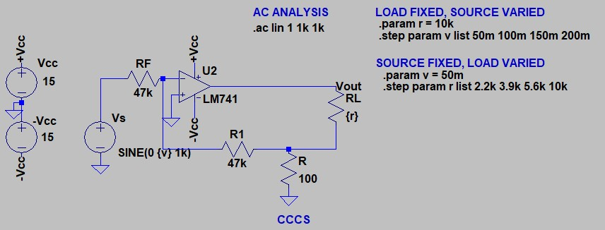

Source Vs = 50mV and load varied

|  |  |
| --- | --- |
|  |  |
|  |  |

Load Rl = 10kΩ and source varied

|  |  |
| --- | --- |
|  |  |
|  |  |

Comparison of simulated and theoretical values

|  |  |  |  |
| --- | --- | --- | --- |
| **Vs (mV)** | **Rl (kΩ)** | **Simulated Ai** | **Theoretical Ai = 1 + (R1/R)** |
| 50 | 2.2 | 53.455683 dB = 470.7433 A/A | 1 + (47kΩ/100Ω) = 471 A/A |
| 50 | 3.9 | 53.448248 dB = 470.3405 A/A | 1 + (47kΩ/100Ω) = 471 A/A |
| 50 | 5.6 | 54.437428 dB = 469.755 A/A | 1 + (47kΩ/100Ω) = 471 A/A |
| 50 | 10 | 54.393902 dB = 467.4069 A/A | 1 + (47kΩ/100Ω) = 471 A/A |
|  |  |  |  |
| 50 | 10 | 54.393902 dB = 467.4069 A/A | 1 + (47kΩ/100Ω) = 471 A/A |
| 100 | 10 | 54.393902 dB = 467.4069 A/A | 1 + (47kΩ/100Ω) = 471 A/A |
| 150 | 10 | 54.393902 dB = 467.4069 A/A | 1 + (47kΩ/100Ω) = 471 A/A |
| 200 | 10 | 54.393902 dB = 467.4069 A/A | 1 + (47kΩ/100Ω) = 471 A/A |